Announcements – Week of July 24 & 25, 2021
St. Peter’s-at-the-Light Episcopal Church, Barnegat Light, NJ

Note:
If you are visiting us for the first time since the pandemic hit, please pick up and read the welcome page that sets forth our general in-person worship guidance.
Please be sure to complete and leave the information card so that we can reach you if needed.

~ ~ ~ ~ ~ ~ ~ ~ ~ ~ ~ ~

Ah.. the joy of new beginnings!
Reading, writing, and Arithmetic anyone? With school reopening in two short months, the Ministry and Outreach committee will be donating backpacks for kids in need in our area. There’s nothing like new school supplies to generate enthusiasm for a new year of learning!
Please consider donating as we purchase backpacks complete with school essentials like pens and pencils and water bottles. These will be ordered, packed and blessed before sending off. You can come help pack during our packing party!
One packed backpack will cost $50, but any size donation will help. Please send your check to the church office at P.O. Box 428, Barnegat Light, NJ 08006-0428 with a note indicating “Backpacks for kids”. You can also leave a check in the offering basket on the back table of the church during any service, or during the Tuesday Open House.
Backpack packing party … the first week in August. Details to follow. Let’s have a pot-luck breakfast and some community fellowship at the same time! Once the backpacks are packed, they will be blessed and delivered to Ocean Community Church for distribution to the children who need them.

Something to Remember
The Parish Office is closed this week. If you have need of assistance this week, please call Genevieve at (914) 815 - 8500. If Genevieve is not available, please call Susan at (609) 709 – 1833.
Note: The Vicar’s schedule for the week is not clear, due to family illness.

Food Ministry
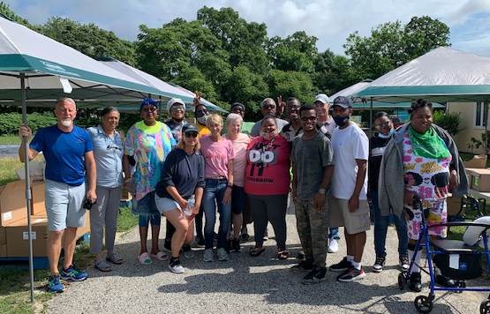
Neighbors are hungry. Can you help? Whether you are a year-round member or a short-term visitor, you can make a difference to neighbors in need. We need many hands preparing and distributing boxes of food for distribution to our neighbors who are struggling. The next day of preparations (organizing and packing) will take place at St. Mary’s in Pleasantville on Monday July 26th. The next food distribution date is Tuesday July 27th. If you can spare a few hours on any of these days, we would be very grateful. Many hands lighten the load.
Have questions? Please call or email Don at (609) 902 – 7487 or Dfmann123@gmail.com
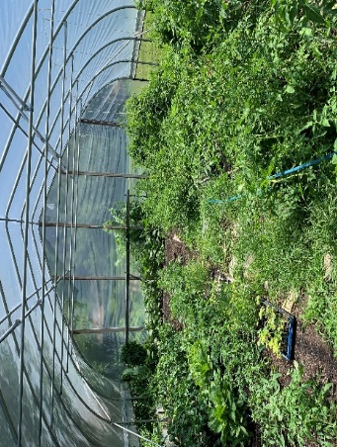
And then there’s the community garden!
We also need many hands to help with the St. Mary’s community garden. If you can spare a few hours on a Tuesday, it’s time for watering, weeding, harvesting, and supporting the garden crew! Again, Don Mann is the “go to” question answerer! (609) 902 – 7487 or Dfmann123@gmail.com

Do not neglect to show hospitality to strangers,
for thereby some have been surprised to entertain angels.
Hebrews 13:2

Help!!! We need YOU!!! It’s a simple but really beautiful way you can serve God’s people! We need Water Ministers and Welcome (Open House) Ministers and Fellowship hour hosts (Saturday evening and Sunday morning)! Let our community be a place where people find peaceful refuge after the storms over the past 18 months. Christian Hospitality is a beautiful and important way to touch others… If you are worshiping in-person, please sign up using the lists in the binder on the back table in church. If you are worshiping online, please let Susan Blauvelt or Chris know when you can help.
- A Water Minister will come to the garden at scheduled times to refill the water and ice in the cooler with supplies from the parish house. You can pick a week (or two!) and schedule your re-fill visits as it is convenient for you.
- A Welcome Minster will come to the Church on Tuesdays, starting in July, to welcome guests and to welcome them to visit our church. We’ll make sure you have all the information you need in advance.
- Fellowship Ministers will arrange snacks and beverages for after all weekend services (Saturday and Sunday).

Please Calendar These Upcoming Events

Saturday, July 24th, 5:00 p.m. –Eucharist (in-person & remote), followed by fellowship
Zoom.us Meeting ID: 820 1378 0402 Passcode: 629607
Sunday, July 25th, 10:00 a.m. –Eucharist (in-person & remote), followed by fellowship
Zoom.us Meeting ID: 820 1378 0402 Passcode: 629607
Monday, July 26th – Food Ministry at St. Mary’s (organizing and packing) - See announcements page 2
Tuesday, July 27th – Food Ministry Distribtion at St. Mary’s - See Announcements page 2
Wednesday, July 28th, noon – In-person and remote Eucharist (to include Healing Prayers)
Zoom.us Meeting ID: 820 1378 0402 Passcode: 629607
Wednesday, July 28th, 6:00 p.m. – Bible Study (online) – come reflect together on the gospel of Luke
Zoom.us Meeting ID: 812 3145 2236 Passcode 210486
Saturday, July 31st, 5:00 p.m. – Eucharist (in-person & remote), followed by fellowship
Zoom.us Meeting ID: 820 1378 0402 Passcode: 629607
Sunday, Aug. 1st, 10:00 a.m. Eucharist (In-person and remote), followed by fellowship
Zoom.us Meeting ID: 820 1378 0402 Passcode: 629607
~ ~ ~ ~ ~ ~ ~ ~ ~ ~ ~ ~

… Our 2021 Mission Committee . . .
Genevieve Bishop, Vicar | Stpeterslbi.vicar@gmail.com  914 – 815 – 8948
Susan Blauvelt, Senior Warden | susanblauvelt@aol.com  609-709-1833
Don Mann, Junior Warden | dfmann123@gmail.com
Greg Albright, Treasurer | gregory.albright@arcadis.com
Sue Hofer, Member | Nightbird526@comcast.net
Maribeth McGrover, Member | maribeth310@gmail.com
Linda Pugliese, Member | nlpugliese@earthlink.net

