**Sixth Sunday of Easter**



**May 25, 2025**

**St. Peter’s-at-the Light Episcopal Church**

**Barnegat Light**

Website: www.stpeterslbi.org

***Thank you for worshipping with us this week.***

***May this worship truly honor God.***

***May it also be for you a time of blessing.***

***Altar Flowers are given by Marguerite & Arthur Hixson***

***in celebration of their wedding anniversary***

To minimize distractions during worship, we do not “pass the plate” during the service. Still, we are very grateful for contributions to support our ministries. You can find the offering plate by the door, and you may leave a contribution there either as you enter or as you leave the service. We are always grateful for your presence and for your support!

Genevieve R. Bishop, Vicar

Office phone: (609) 494 – 2398; Office email: officestpeterslbi2@gmail.com

**Sincere thanks to today’s Worship Assistants**

Don Mann, Worship Technology

Bruce Allen, Greeter

Maribeth McGrover, NT Lector 1 & Psalm Leader

Len Van Orden, NT Lector 2

Pascual Rodriguez, Litanist

Laura Van Orden, Acolyte & Eucharistic Minister of the Sipping Chalice

Salli Gordon, Eucharistic Minister of the Intinction Chalice

Laura Van Orden, Eucharistic visitors

Barbara Wheeler, Organist

**Counters**

Joan Malara & Len Van Orden

All music herein is reprinted under Ritesong permission for one-time use and streaming

or under OneLicense # A727343

***Please stand* Entrance Rite**

## Entrance Hymn *Come, Ye Disconsolate LEVAS # 147*

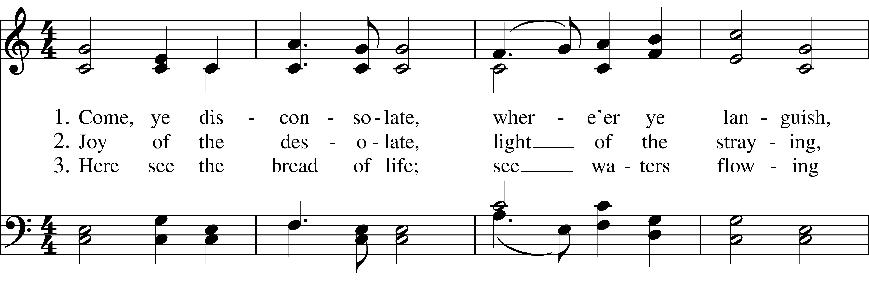  
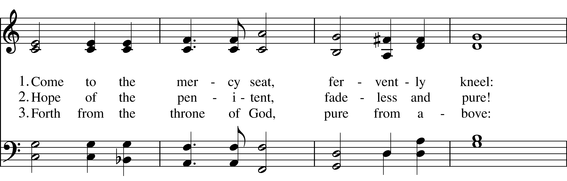  
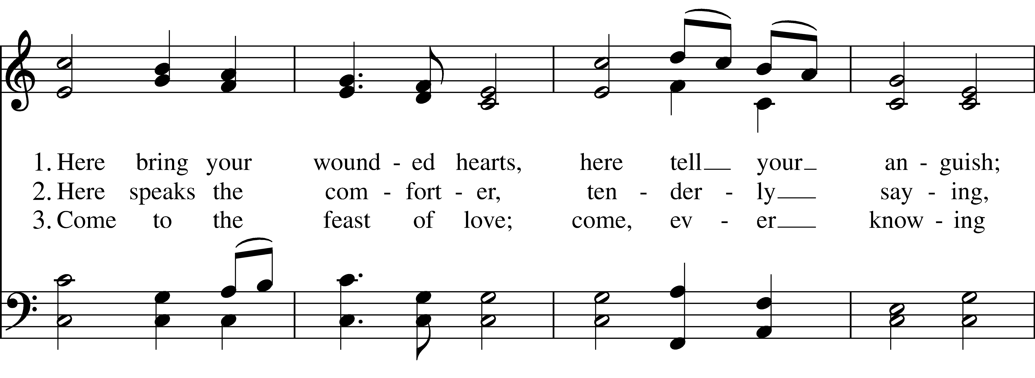  
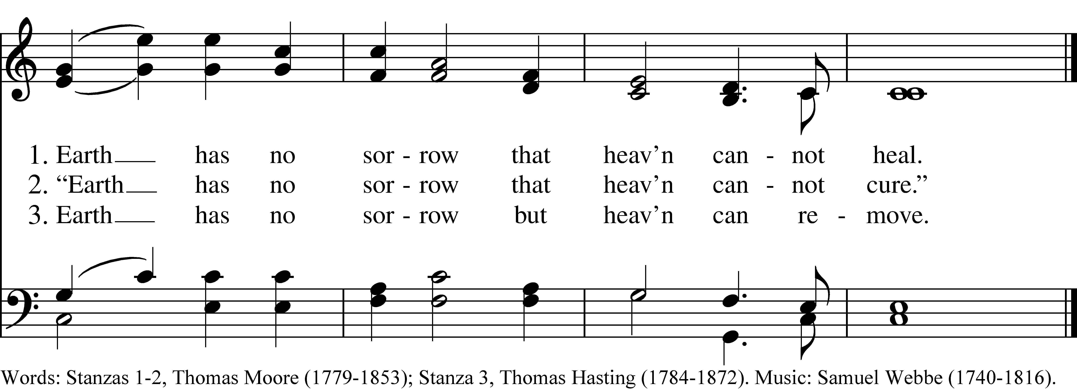

Celebrant: Alleluia! Christ is risen.

**All: The Lord is risen indeed. Alleluia!**

Celebrant: Almighty God, to you all hearts are open, all desiresknown, and from you no secrets are hid. Cleanse the thoughts of our hearts by the inspiration of your Holy Spirit, that we may perfectly love you, and worthily magnify your holy Name. Through Christ our Lord.

**All: Amen.**

**Hymn of Praise**  *Glory to God*  ***Hymnal # S - 280***

*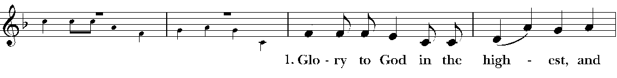  
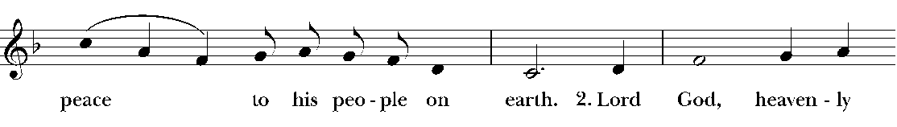  
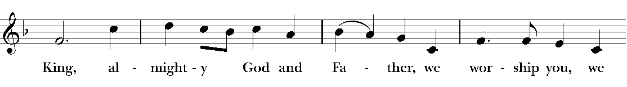  
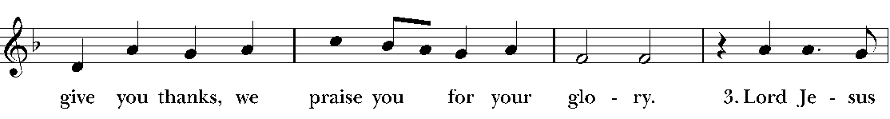  
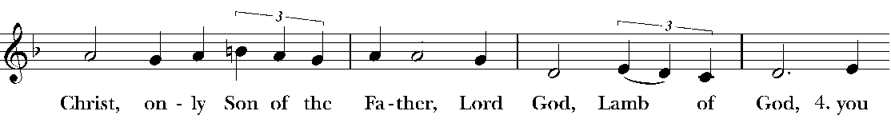  
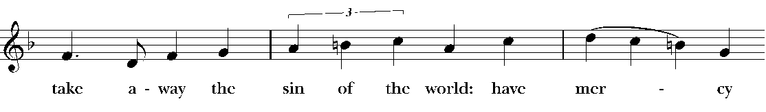  
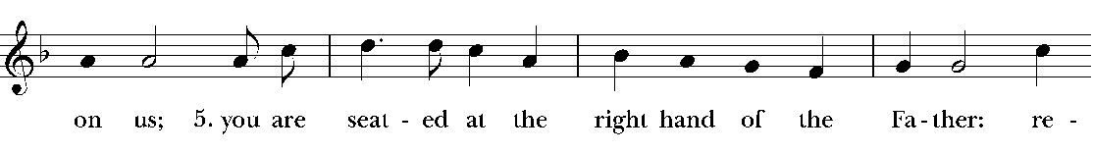  
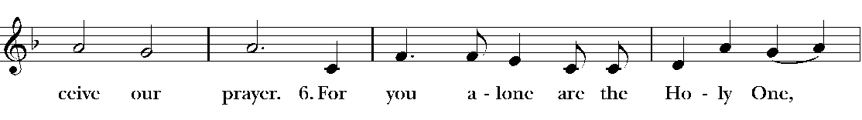  
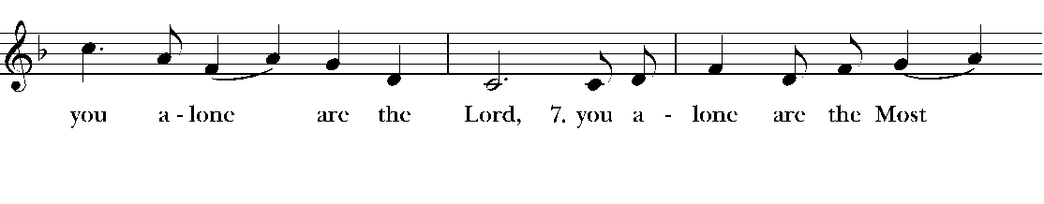  
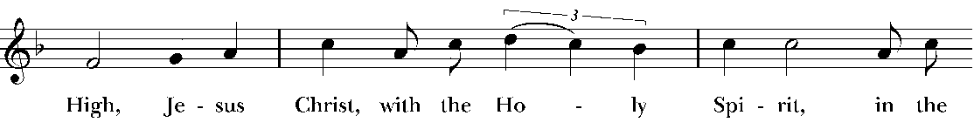  
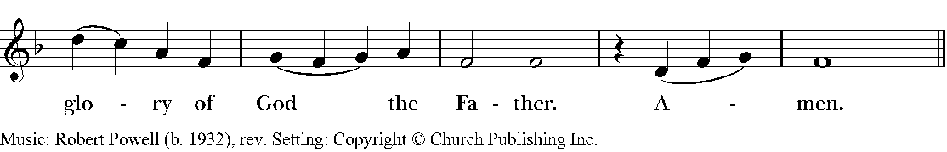*

Celebrant: The Lord be with you.

**All: And also with you.**

Celebrant: Let us pray:

***The Collect for the Sixth Sunday of Easter, page 225 in the Book of Common Prayer.***

Celebrant: O God, you have prepared for those who love you such good things as surpass our understanding: Pour into our hearts such love towards you, that we, loving you in all things and above all things, may obtain your promises, which exceed all that we can desire; through Jesus Christ our Lord, who lives and reigns with you and the Holy Spirit, one God, for ever and ever.

**All: Amen.**

***Please Sit* The Liturgy of the Word**

NT Lector 1: The first reading is from the book “Acts” *Acts 16:9-15*

9 During the night Paul had a vision: there stood a man of Macedonia pleading with him and saying, “Come over to Macedonia and help us.”10 When he had seen the vision, we immediately tried to cross over to Macedonia, being convinced that God had called us to proclaim the good news to them. 11 We set sail from Troas and took a straight course to Samothrace, the following day to Neapolis, 12 and from there to Philippi, which is a leading city of the district of Macedonia and a Roman colony. We remained in this city for some days.

13 On the sabbath day we went outside the gate by the river, where we supposed there was a place of prayer; and we sat down and spoke to the women who had gathered there. 14 A certain woman named Lydia, a worshiper of God, was listening to us. She was from the city of Thyatira and was a dealer in purple cloth. The Lord opened her heart to listen eagerly to what was said by Paul. 15 When she and her household were baptized, she urged us, saying, “If you have judged me to be faithful to the Lord, come and stay at my home.” And she prevailed upon us.

This is the Word of the Lord.

**All: Thanks be to God.**

**NT Lector 1:** We will pray Psalm 67 as our response to this morning’s first reading, praying responsively by half-verse.

1 May God be merciful to us and bless us, *  
       **show us the light of his countenance and come to us.**  
2 Let your ways be known upon earth, *  
       **your saving health among all nations.**3 Let the peoples praise you, O God; *  
       **let all the peoples praise you.**  
4 Let the nations be glad and sing for joy, *  
       **for you judge the peoples with equity  
       and guide all the nations upon earth.**5 Let the peoples praise you, O God; *  
       **let all the peoples praise you.**  
6 The earth has brought forth her increase; *  
       **may God, our own God, give us his blessing.**  
7 May God give us his blessing, *  
       **and may all the ends of the earth stand in awe of him.**

**NT Lector 2**: The second reading is from the book “Revelation” *Rev. 21:10, 21:22-22:5*

10 Then one of the seven angelstook me in the spirit up a great, high mountain and he showed me the holy city, Jerusalem, coming down out of heaven from God.

22 I saw no temple in the city, because the Lord God the Almighty is its temple, together with the Lamb. 23 And the city has no need of sun or moon to shine on it, for the glory of God gives it light, and its lamp is the Lamb. 24 The nations will walk by its light, and the kings of the earth will bring their glory into it. 25 Its gates will never be shut by day—and there will be no night there. 26 They will bring the glory and the honor of the nations into it. 27 Nothing that has not been made holy will ever come into it, nor will anyone who practices abomination or who tells lies, but only those who are written in the Lamb’s book of life.

1 Then the angel showed me the river of the water of life. It was sparkling like crystal, and flowing from the throne of God and of the Lamb 2 through the middle of the street of the city. On either bank of the river was growing the tree of life. It produces twelve kinds of fruit, producing its fruit each month; and the leaves of the tree are for the healing of the nations. 3 Nothing accursed is there anymore. Rather, the throne of God and of the Lamb are in the city, and his servants will worship him. 4 They will see his face, and his name will be on their foreheads. 5 There will be no more night, and they will not need the light of lamp or the light of the sun, because the Lord God will shine on them, and they will reign forever and ever.

This is the Word of the Lord.

**All: Thanks be to God.**

***Please stand for the Gospel Acclamation***

**Hymn**  *Christ Has Arisen, Alleluia!* ***LEVAS # 41***

***Played once then sung twice***

Celebrant: The Holy Gospel of Jesus Christ according to John *John 5:1-9*

**All: Glory to you, Lord Christ**

1 After this there was a Jewish festival, and Jesus went up to Jerusalem.

2 In Jerusalem, near the Sheep Gate, there is a pool which is called in Hebrew Bethesda. It has five porticoes3 where there were several sick people lying. Some were blind; some were lame; some were paralyzed.

5 There was a man who had been in the same sick condition for thirty-eight years.6 Jesus saw him lying there and knew that the man had been there a long time already.

“Do you want to get well?” Jesus asked him.

7 “Well, sir,”the sick man answered him, “I have no one to put me into the pool when the water is stirred up; and while I am making my way, someone else steps down ahead of me.”

8 “Get up,” said Jesus, “pick up your mat and walk!”

9 At once the man was healed. He took up his mat and began to walk.

The day that all this happened was a sabbath.

This is the Gospel of the Lord.

**All: Praise to you, Lord Christ.**

***God does not play by our rules!***

***Please stand***

**Celebrant: Let us profess our faith using the words of the Nicene Creed**

**We believe in one God,**

**the Father, the Almighty,**

**maker of heaven and earth,**

**of all that is, seen and unseen.**

**We believe in one Lord, Jesus Christ,**

**the only Son of God,**

**eternally begotten of the Father,**

**God from God, Light from Light,**

**true God from true God,**

**begotten, not made,**

**of one Being with the Father.**

**Through him all things were made.**

**For us and for our salvation**

**he came down from heaven:**

**by the power of the Holy Spirit**

**he became incarnate from the Virgin Mary,**

**and was made man.**

**For our sake he was crucified under Pontius Pilate;**

**he suffered death and was buried.**

**On the third day he rose again**

**in accordance with the Scriptures;**

**he ascended into heaven**

**and is seated at the right hand of the Father.**

**He will come again in glory to judge the living and the dead,**

**and his kingdom will have no end.**

**We believe in the Holy Spirit, the Lord, the giver of life,**

**who proceeds from the Father and the Son.**

**With the Father and the Son he is worshiped and glorified.**

**He has spoken through the Prophets.**

**We believe in one holy catholic and apostolic Church.**

**We acknowledge one baptism for the forgiveness of sins.**

**We look for the resurrection of the dead,**

**and the life of the world to come. Amen.**

**The Prayers of the People**

Priest: We come today as those who strive to witness to the hope that springs from the resurrection of Jesus, and we present now to our God the concerns of our hearts:

Litanist: Jesus, you triumphed over evil and death, and so brought hope to all the world:  Speak your living truth into the hearts of those who lead and hold authority among the nations, that they may become agents of life and justice. Alleluia!  Christ is risen.

**All:** **The Lord is risen indeed.  Alleluia!**

Litanist: Jesus, you speak so that all who seek you can truly know you. Pour out your Spirit upon the leaders of your church, and especially upon Presiding Bishop Sean and upon our Bishop Sally. Grant them the capacity to hear and faithfully respond to your voice. May we remain faithful to the work you entrust to us, the work of restoring all people to unity with God and each other in your name. Alleluia!  Christ is risen.

**All: The Lord is risen indeed.  Alleluia!**

Litanist: Jesus, you ask us to be faithful and joyous witnesses to your resurrection. Make us courageous in proclaiming your goodness and love. Alleluia!  Christ is risen.

**All: The Lord is risen indeed.  Alleluia!**

Litanist: Jesus, you are the wounded healer who has overcome all evil and all things we fear. Let the power of your resurrection bring healing and hope to those throughout the world who suffer this day. We entrust to your hand the needs of all who are on our prayer list, represented today by these names:

Deacon **Carolsue** Cummings, **Althea** Martie**, Carolyn** N.**, Eugene** R., **Allacen & Craig** Rathbun, **Ken** Reid, Jr., **Trey & Kelly** Rhodes, **Kay** Roberts, **Tomm** Robinson, **Diana** Rodriguez, **Judy** Rosenberg, **Tara** Shannon, **Derek** Shinn, **Bob & Cynthia** Shull, **Joseph** Smith, **Barbara** Sweeton, **Dennis** Tsirikos, **Candy** Turner, **Jan** Viviani, **Mary & Bob** Wilding, **Steve** Zarrillo and **Al** Zofchak

Because we trust the power of your resurrection, we pray with confidence for all of these. Alleluia!  Christ is risen.

**All: The Lord is risen indeed.  Alleluia!**

Litanist: Lord Jesus, as we move closer to the summer season in our little community, give us hearts that embrace without judgment all those who visit us. We trust that, by your grace and power, our visitors this year will find in us a place of true respite and renewal. Alleluia! Christ is risen.

**All: The Lord is risen indeed. Alleluia!**

*The priest will invite other petitions here.*

Priest:  Gracious Eternal and Loving God, you anointed Jesus of Nazareth with the Holy Spirit and with power, and raised him from death on the cross into resurrection life:  Nourish us with his life as we eat and drink with him in this Easter season Eucharist, that we may truly be his witnesses, sharing in the Spirit’s work of reconciliation and peace, through the Risen Jesus Christ our Savior.

**All: Amen.**

*Let us now offer each other a greeting of peace.*

***Please Be Seated*** **The Liturgy of the Table**

Hymn as the Table is Set *Come, Thou Font of Ev’ry Blessing* ***LEVAS 111***

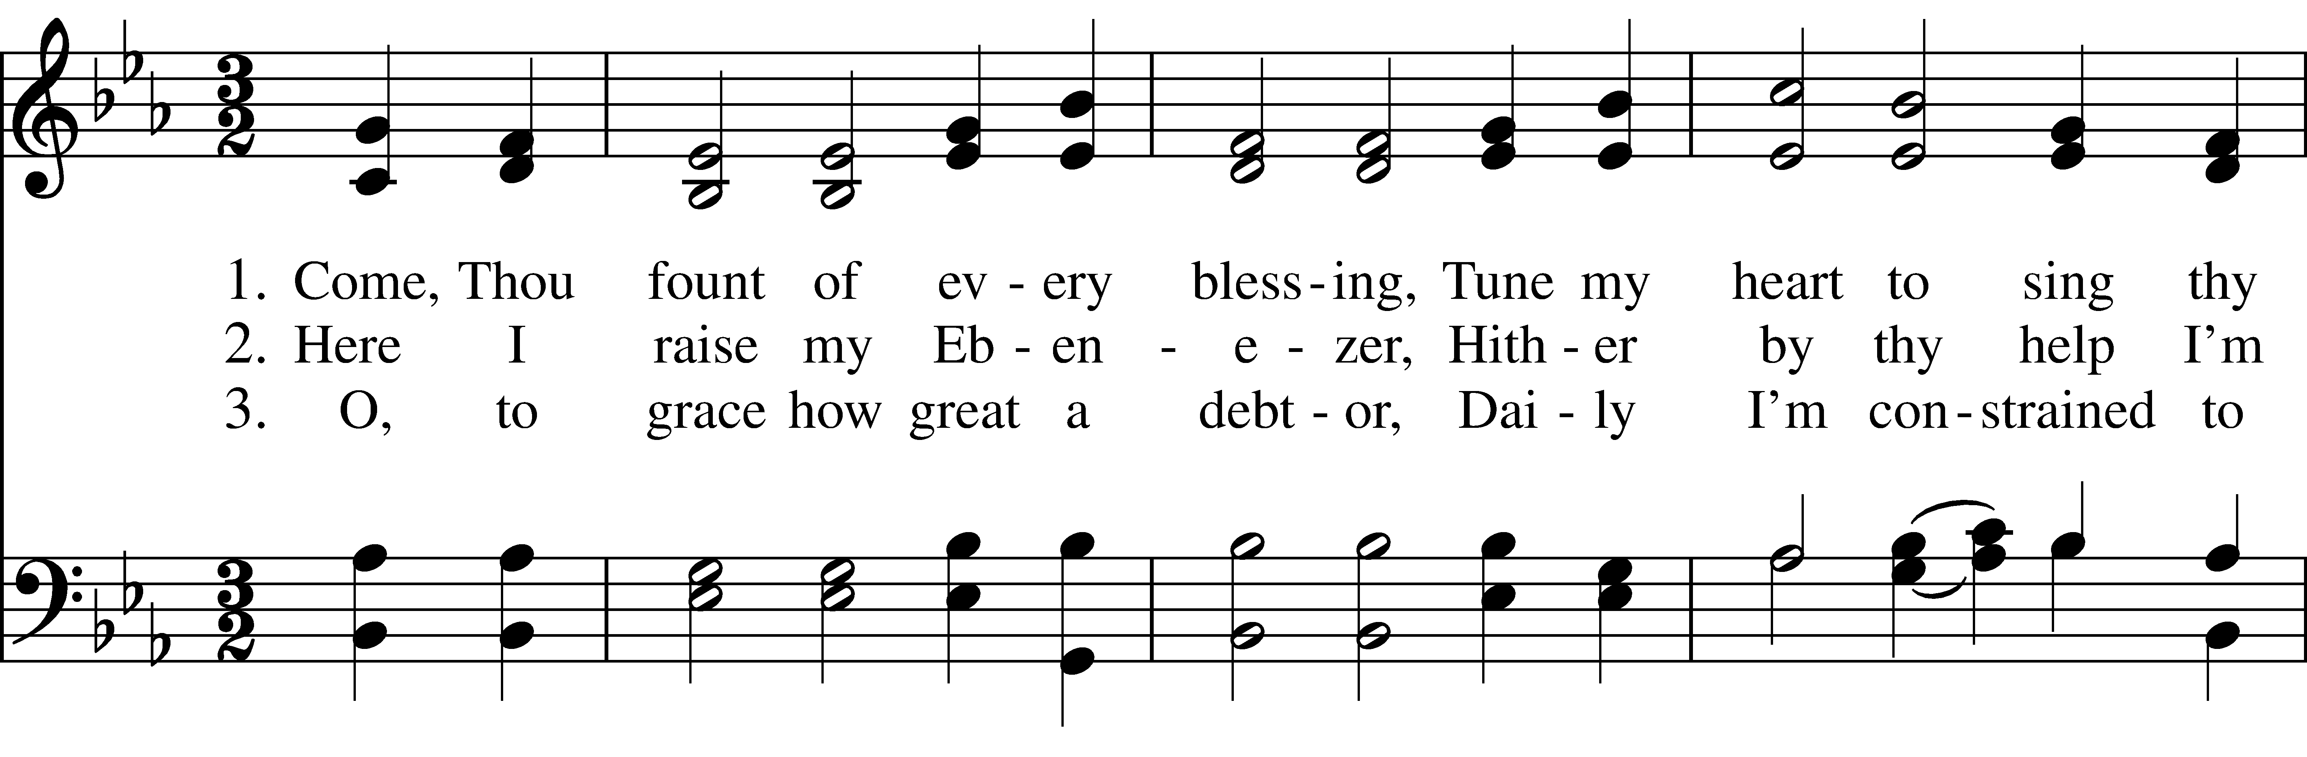  
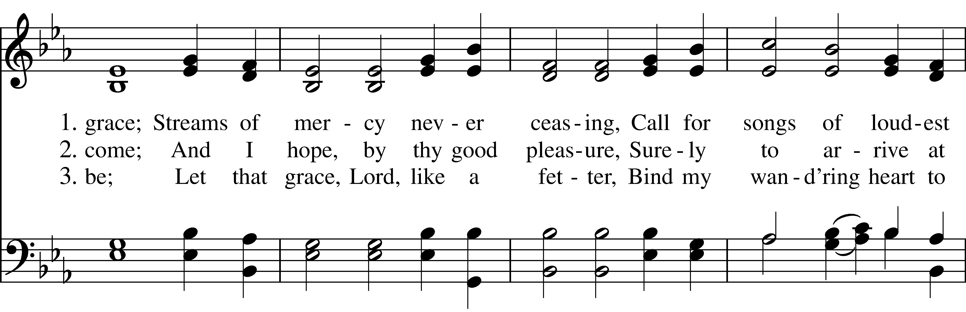  
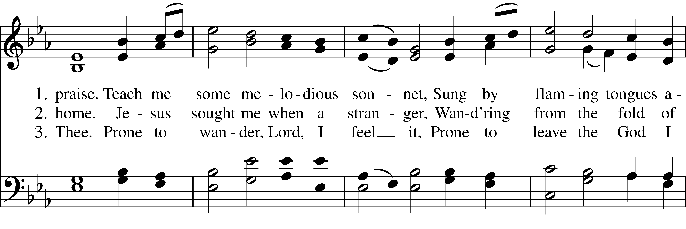  
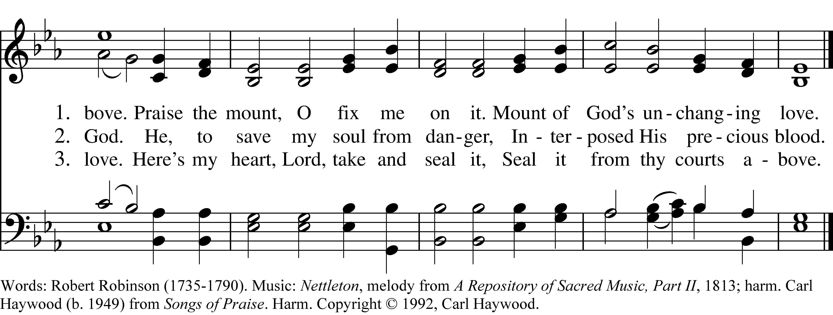

***Please stand***

*We are praying Eucharistic Prayer B during this Easter Season. It begins on* ***page 367*** *in the BCP.*

Priest: The Lord be with you.

**All: And also with you.**

Priest: Lift up your hearts.

**All: We lift them to the Lord.**

Priest: Let us give thanks to the Lord our God.

**All: It is right to give him thanks and praise.**

Priest: It is right, and a good and joyful thing, always and everywhere to give thanks to you, Father Almighty, Creator of heaven and earth. But chiefly are we bound to praise you for the glorious resurrection of your Son Jesus Christ our Lord; For he is the true Paschal Lamb, who was sacrificed for us, and has taken away the sin of the world. By his death he has destroyed death, and by his rising to life again, he has won for us everlasting life. Therefore we praise you, joining our voices with Angels and Archangels, and with all the company of heaven, who for ever sing this hymn to proclaim the glory of your Name:

**Sanctus *Hymnal # S-125***

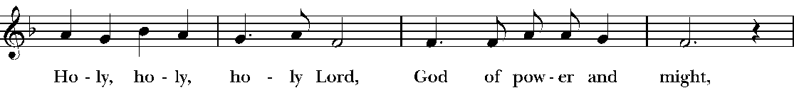  
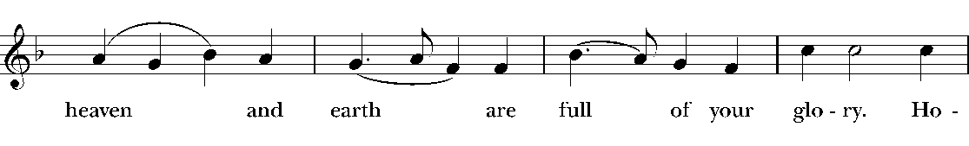  
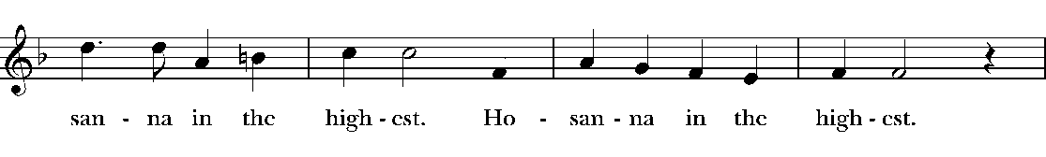  
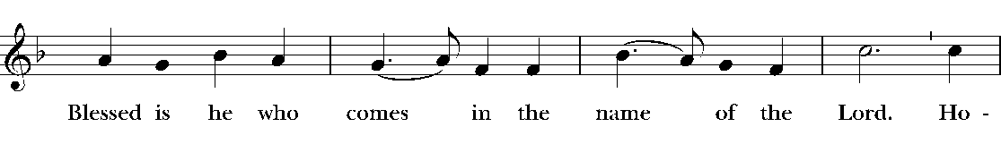  
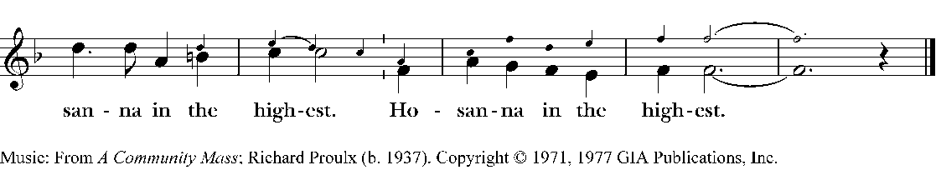

Priest: We give thanks to you, O God, for the goodness and love which you have made known to us in creation; in the calling of Israel to be your people; in your Word spoken through the prophets; and above all in the Word made flesh, Jesus, your Son. For in these last days you sent him to be incarnate from the Virgin Mary, to be the Savior and Redeemer of the world. In him, you have delivered us from evil, and made us worthy to stand before you. In him, you have brought us out of error into truth, out of sin into righteousness, out of death into life.

On the night before he died for us, our Lord Jesus Christ took bread; and when he had given thanks to you, he broke it, and gave it to his disciples, and said, "Take, eat: This is my Body, which is given for you. Do this for the remembrance of me."

After supper he took the cup of wine; and when he had given thanks, he gave it to them, and said, "Drink this, all of you: This is my Blood of the new Covenant, which is shed for you and for many for the forgiveness of sins. Whenever you drink it, do this for the remembrance of me."

Therefore, according to his command, O Father,

**All: We remember his death,**

**We proclaim his resurrection,**

**We await his coming in glory.**

Priest: And we offer our sacrifice of praise and thanksgiving to you, O Lord of all; presenting to you, from your creation, this bread and this wine. We pray you, gracious God, to send your Holy Spirit upon these gifts that they may be the Sacrament of the Body of Christ and his Blood of the new Covenant. Unite us to your Son in his sacrifice, that we may be acceptable through him, being sanctified by the Holy Spirit. In the fullness of time, put all things in subjection under your Christ, and bring us to that heavenly country where, with all your saints, we may enter the everlasting heritage of your sons and daughters; through Jesus Christ our Lord, the firstborn of all creation, the head of the Church, and the author of our salvation.

By him, and with him, and in him, in the unity of the Holy Spirit all honor and glory is yours, Almighty Father, now and for ever.

**Amen *Hymnal # 146***

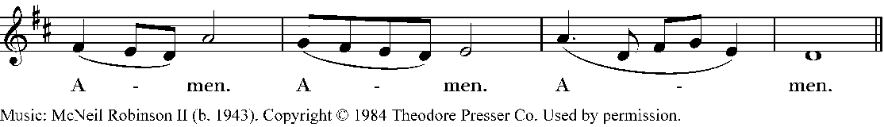

***Although we will collectively use the contemporary form of the Lord’s Prayer, you are encouraged to pray this prayer aloud in the language that comes from your heart.***

Priest: As our Savior Christ has taught us, we now pray,

**Our Father in heaven, Our Father, who art in heaven,**

**hallowed be your Name. hallowed be thy Name.**

**Your kingdom come, Thy kingdom come,**

**your will be done, Thy will be done,**

**on earth as in heaven. On earth as it is in heaven.**

**Give us today our daily bread. Give us this day our daily bread,**

**Forgive us our sins and forgive us our trespasses,**

**as we forgive those As we forgive those**

**who sin against us. Who trespass against us.**

**Save us from the time of trial, And lead us not into temptation,**

**and deliver us from evil. But deliver us from evil.**

**For the kingdom, the power, For Thine is the kingdom,**

**and the glory are yours, and the power, and the glory,**

**now and for ever. Amen. For ever and ever. Amen.**

***To Partake of Communion or to Receive a Blessing***

*Those who wish to partake of Holy Communion may come to the altar rail. The railing is our way of extending the Lord’s table. If you wish to receive only a blessing, cross your arms over your chest.*

*If you prefer a wafer to a small piece of bread, please hold your hands out but facing your hands toward the floor.*

*If you need a gluten free host, please place your right hand on your left shoulder.*

*To receive only the communion bread, consume the host after it is in your hands; then return to your pew.*

*If you wish to receive communion bread and dip it in the consecrated wine, remain at the altar rail and hold the bread or host in your hand until the gold chalice comes to you. Then dip the host into the wine and consume the communion bread and wine.*

*If you wish to consume the host and then sip from the chalice, leave the altar rail after you consume the bread or host and move to the Eucharistic Minister with the silver sipping chalice at the left side of the altar rail.*

*Always, you may either stand or kneel at the altar rail, as you prefer.*

Celebrant: Alleluia! Christ, our Passover, is sacrificed for us.

**All: Therefore, let us keep the feast! Alleluia!**

***Please be seated as we prepare to distribute Communion.***

***This is the Lord’s Table. All are welcome here.***

Celebrant: These are the gifts of God, for the People of God. Take them in remembrance that Christ died for you, and feed on him in your hearts by faith, with thanksgiving.

Post-Communion Hymn: *It Is Well With My Soul* ***LEVAS # 188***

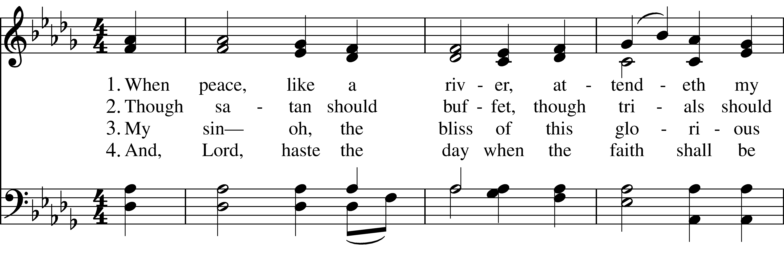  
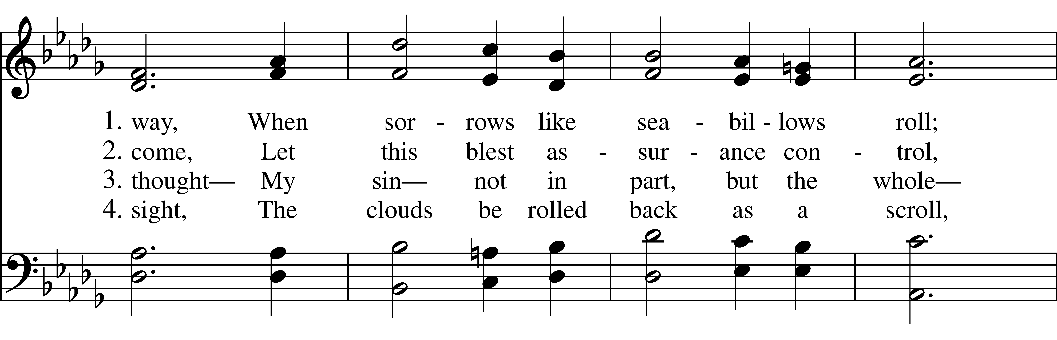  
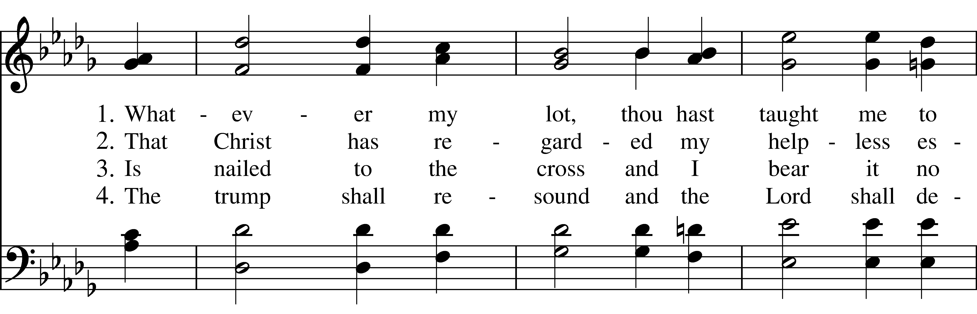  
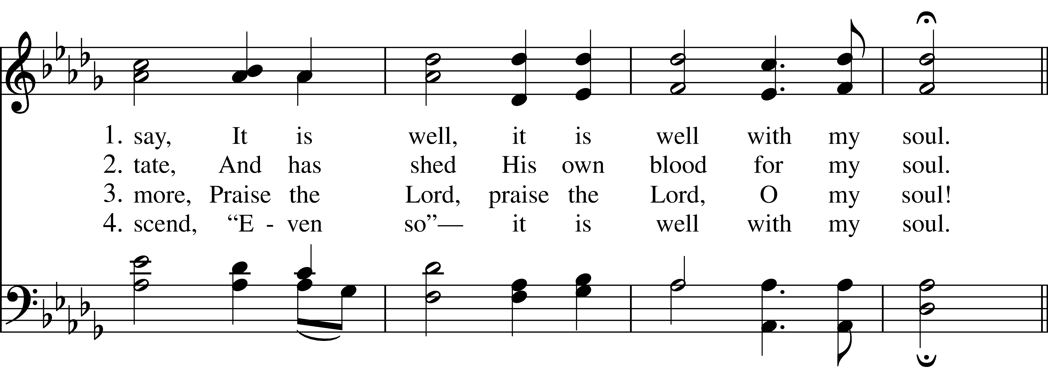  
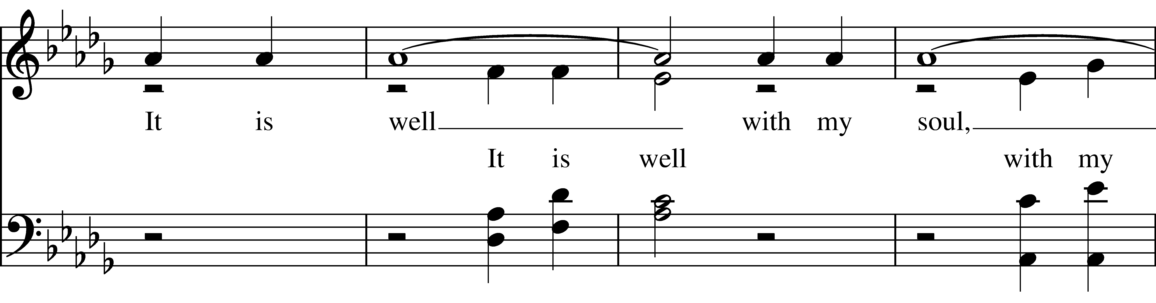  
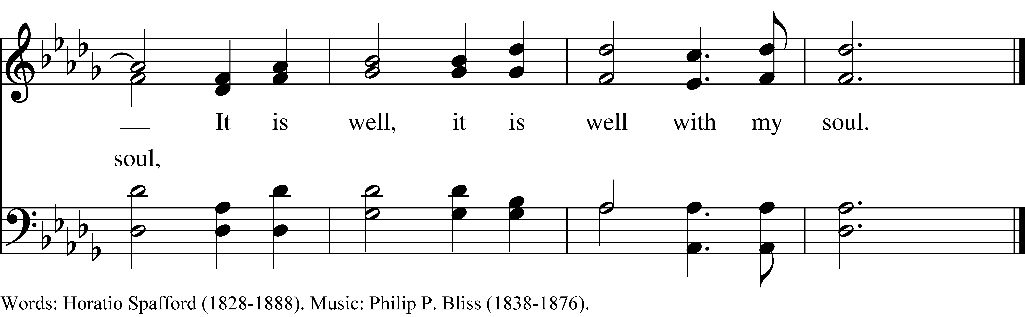

## Post-communion Prayer – BCP 366

Priest*:*  Let us pray together once again.

**All: Almighty and everliving God,**

**We thank you for feeding us with the spiritual food**

**of the most precious Body and Blood**

**of your Son our Savior Jesus Christ;**

**and for assuring us in these holy mysteries**

**that we are living members of the Body of your Son,**

**and heirs of your eternal kingdom.**

**And now, Father, send us out**

**to do the work you have given us to do,**

**to love and serve you**

**as faithful witnesses of Christ our Lord.**

**To him to you, and to the Holy Spirit,**

**to honor and glory, now and for ever. Amen.**

*The Eucharistic Visitors will now come forward to be blessed and sent by our community.*

*The priest will offer a prayer of blessing for this ministry.*

*The community will then commission the Eucharistic Visitors to bring the Communion Bread and Wine to the homebound and their families by these words:*

**All: Barbara and Laura,**

**we now send you forth**

**as representatives of this community,**

**to bear these holy gifts,**

**the Sacrament of the body and blood,**

**the presence of Jesus.**

**We desire that those to whom you go**

**may share with us in the communion of Christ’s body and blood.**

**We who are here and those to whom you go,**

**are one body,**

**because we all share one bread, one cup.**

***Announcements***

## *Please stand for the final blessings of this service*

Priest: May God’s Blessing be with you,

May the Risen Christ’s peace be with you,

And may the Spirit’s outpouring fill you with hope and peace

today and always.

### **All: Amen.**

### Sending Hymn: Yes, We’ll Gather at the River **LEVAS # 141**

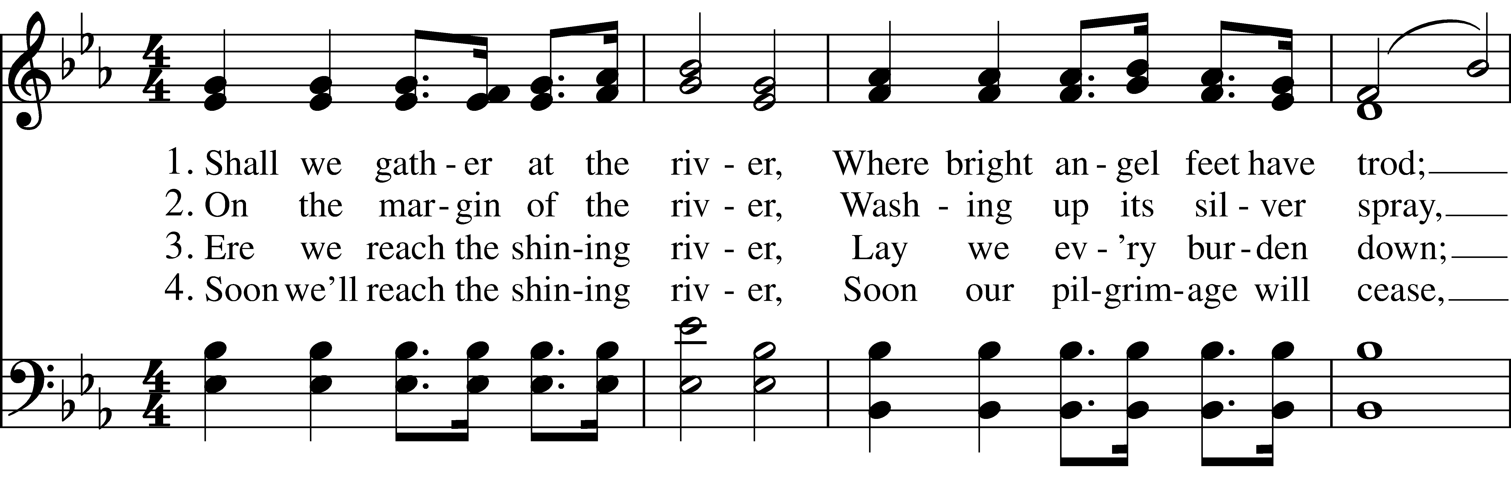  
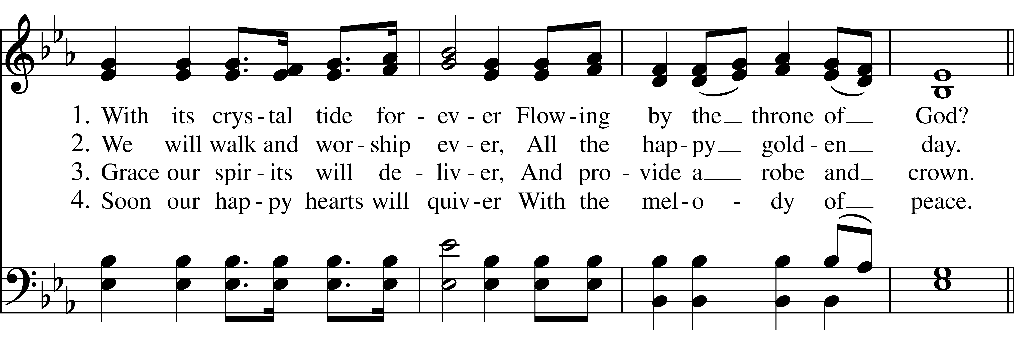  
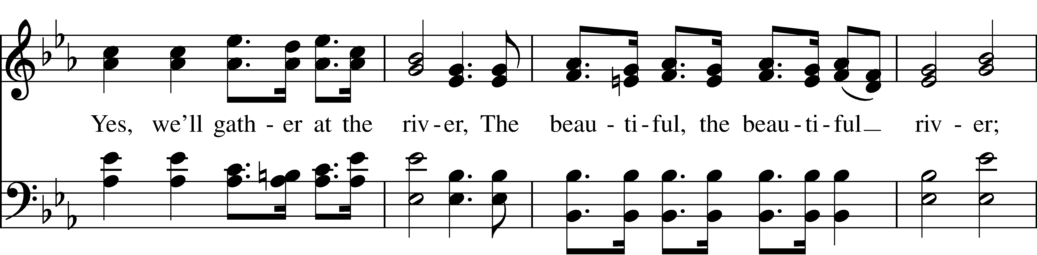  
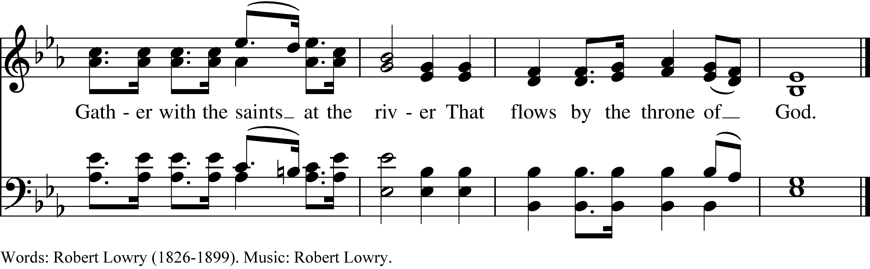

Celebrant: Let us go forth in the name of Christ, Alleluia! Alleluia! Alleluia! .

**All: Thanks be to God.**

***Thank you for worshiping with us today.***

***Please join us, if you can, in the parish house for a time of fellowship.***